Q1)

#include <iostream>

#include <string>

using namespace std;

class Student {

private:

string name;

int age;

public:

Student() {

name = "Devansh";

age = 18;

}

void displayDetails() {

cout << "Student Name: " << name << endl;

cout << "Student Age: " << age << endl;

}

};

int main() {

Student student;

student.displayDetails();

return 0;

}

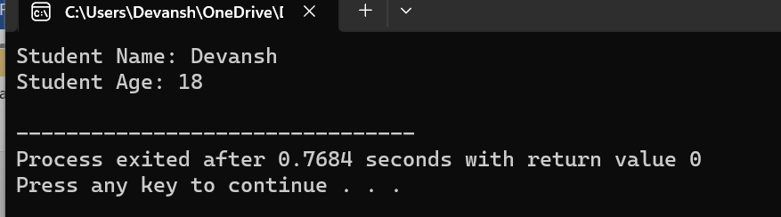

Q2)

#include <iostream>

using namespace std;

class Circle {

private:

float radius;

float area;

public:

Circle(float r) {

radius = r;

area = 3.14 \* radius \* radius;

}

void displayArea() {

cout << "Area of the circle: " << area << " square units" << endl;

}

};

int main() {

float radius;

cout << "Enter the radius of the circle: ";

cin >> radius;

Circle circle(radius);

circle.displayArea();

return 0;

}

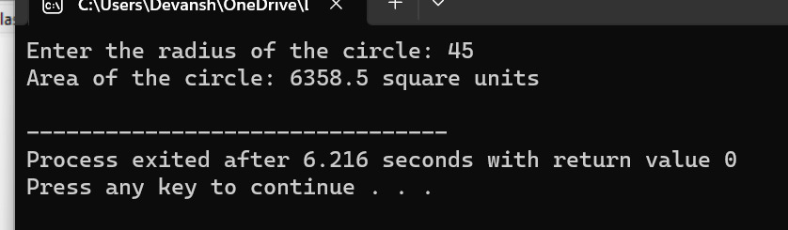

Q3)

#include <iostream>

#include <string>

using namespace std;

class Employee {

private:

string name;

int id;

public:

Employee() {

name = "John Doe";

id = 0;

}

void displayDetails() {

cout << "Employee Name: " << name << endl;

cout << "Employee ID: " << id << endl;

}

};

int main() {

Employee employee;

employee.displayDetails();

return 0;

}

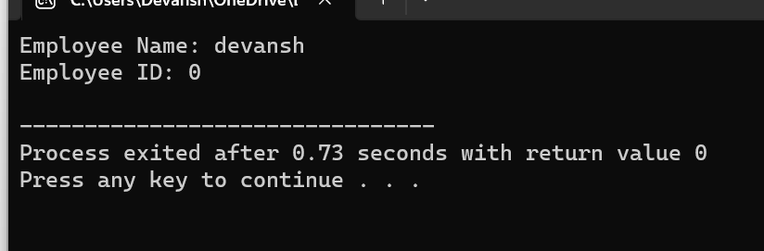

Q4) #include <iostream>

#include <string>

using namespace std;

class Book {

private:

string title;

string author;

float price;

public:

Book(string t, string a, float p) {

title = t;

author = a;

price = p;

}

void displayDetails() {

cout << "Title: " << title << endl;

cout << "Author: " << author << endl;

cout << "Price: $" << price << endl;

}

};

int main() {

string title, author;

float price;

cout << "Enter the title of the book: ";

getline(cin, title);

cout << "Enter the author of the book: ";

getline(cin, author);

cout << "Enter the price of the book: $";

cin >> price;

cin.ignore();

Book book(title, author, price);

book.displayDetails();

return 0;

}

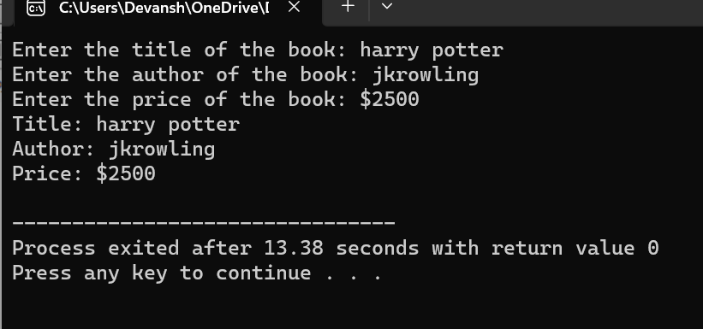

Q5)

#include <iostream>

using namespace std;

class Rectangle {

private:

float length;

float width;

public:

Rectangle() {

length = 0.0;

width = 0.0;

}

void setDimensions(float l, float w) {

length = l;

width = w;

}

float calculateArea() {

return length \* width;

}

void displayArea() {

cout << "Area of the rectangle: " << calculateArea() << " square units" << endl;

}

};

int main() {

Rectangle rectangle;

float length, width;

cout << "Enter the length of the rectangle: ";

cin >> length;

cout << "Enter the width of the rectangle: ";

cin >> width;

rectangle.setDimensions(length, width);

rectangle.displayArea();

return 0;

}

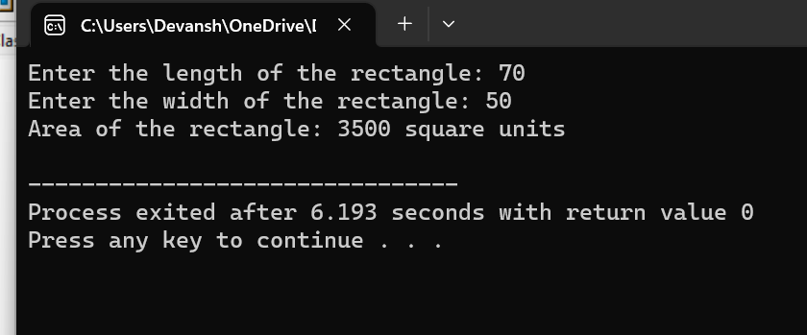

Q6)

#include <iostream>

using namespace std;

class BankAccount {

private:

int accountNumber;

float balance;

public:

BankAccount(int accNum, float initialBalance) {

accountNumber = accNum;

balance = initialBalance;

}

void displayAccountDetails() {

cout << "Account Number: " << accountNumber << endl;

cout << "Balance: $" << balance << endl;

}

void deposit(float amount) {

balance += amount;

cout << "Deposit successful. Updated balance: $" << balance << endl;

}

void withdraw(float amount) {

if (amount > balance) {

cout << "Insufficient balance. Withdrawal canceled." << endl;

} else {

balance -= amount;

cout << "Withdrawal successful. Updated balance: $" << balance << endl;

}

}

};

int main() {

int accountNumber;

float initialBalance, depositAmount, withdrawAmount;

cout << "Enter the account number: ";

cin >> accountNumber;

cout << "Enter the initial balance: $";

cin >> initialBalance;

BankAccount account(accountNumber, initialBalance);

account.displayAccountDetails();

cout << "Enter the amount to deposit: $";

cin >> depositAmount;

account.deposit(depositAmount);

cout << "Enter the amount to withdraw: $";

cin >> withdrawAmount;

account.withdraw(withdrawAmount);

return 0;

}

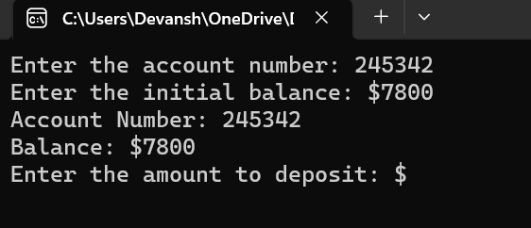

Q7)

#include <iostream>

#include <string>

using namespace std;

class Car {

private:

string brand;

string model;

public:

Car(string b, string m) {

brand = b;

model = m;

}

void displayDetails() {

cout << "Car Brand: " << brand << endl;

cout << "Car Model: " << model << endl;

}

};

int main() {

string brand, model;

cout << "Enter the car brand: ";

getline(cin, brand);

cout << "Enter the car model: ";

getline(cin, model);

Car car(brand, model);

car.displayDetails();

return 0;

}

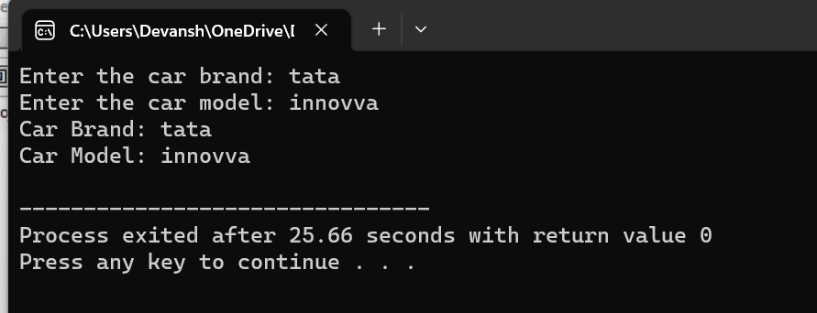

Q8)

#include <iostream>

using namespace std;

class Time {

private:

int hours;

int minutes;

int seconds;

public:

Time(int h, int m, int s) {

hours = h;

minutes = m;

seconds = s;

}

void displayTime() {

string meridian = (hours < 12) ? "AM" : "PM";

int displayHours = (hours > 12) ? hours - 12 : hours;

cout << "Time: " << displayHours << ":";

if (minutes < 10) {

cout << "0" << minutes;

} else {

cout << minutes;

}

if (seconds < 10) {

cout << ":0" << seconds;

} else {

cout << ":" << seconds;

}

cout << " " << meridian << endl;

}

};

int main() {

int hours, minutes, seconds;

cout << "Enter the hours: ";

cin >> hours;

cout << "Enter the minutes: ";

cin >> minutes;

cout << "Enter the seconds: ";

cin >> seconds;

Time time(hours, minutes, seconds);

time.displayTime();

return 0;

}

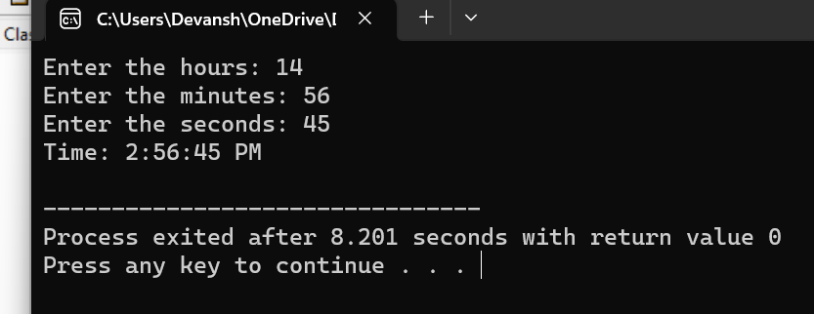

Q9)

#include <iostream>

#include <string>

using namespace std;

class Person {

private:

string name;

int age;

public:

Person() {

name = "Unknown";

age = 0;

}

void setDetails(string n, int a) {

name = n;

age = a;

}

void displayDetails() {

cout << "Name: " << name << endl;

cout << "Age: " << age << endl;

}

};

int main() {

Person person;

string name;

int age;

cout << "Enter the person's name: ";

getline(cin, name);

cout << "Enter the person's age: ";

cin >> age;

person.setDetails(name, age);

person.displayDetails();

return 0;

}

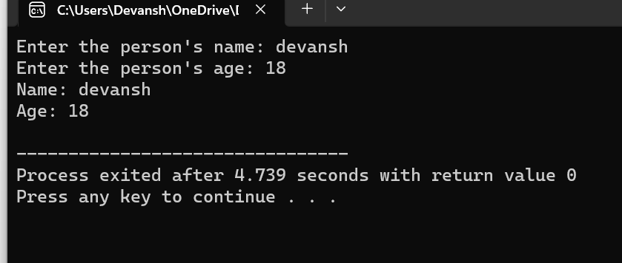

Q10)

#include <iostream>

using namespace std;

class Triangle {

private:

double side1;

double side2;

double side3;

public:

Triangle(double s1, double s2, double s3) {

side1 = s1;

side2 = s2;

side3 = s3;

}

double calculatePerimeter() {

return side1 + side2 + side3;

}

void displayPerimeter() {

cout << "Perimeter of the triangle: " << calculatePerimeter() << endl;

}

};

int main() {

double side1, side2, side3;

cout << "Enter the length of side 1: ";

cin >> side1;

cout << "Enter the length of side 2: ";

cin >> side2;

cout << "Enter the length of side 3: ";

cin >> side3;

Triangle triangle(side1, side2, side3);

triangle.displayPerimeter();

return 0;

}

